Physics | Topic/ Objective:  Unit 3: Forces | Name:
 |  | Period: Date:
Essential Question: How can forces predict motion?
Questions: | Notes:
How do scientists describe and measure forces? | When forces are combined, ________ forces can be added. Note: __________ are established using (+) and (-) signs.  When forces are in opposite directions, the _____ force is the in _________ of the largest force.  When multiple forces act on object,  all of the forces can be added together to find the  _____ __________ (____or_____) on the object.
How do forces combine?
Force Vector Addition Samples:

+ 4N + + 3N = + 7N

+ 4N + - 3N = + 1N
Magnitude: Angle: *
(4N)² + (3N)² = R² θ = tan ⁻¹ ( 3N/4N)
116N² + 9N² = R² θ = 37º
25N² = R²
5N = R * ALG II students only

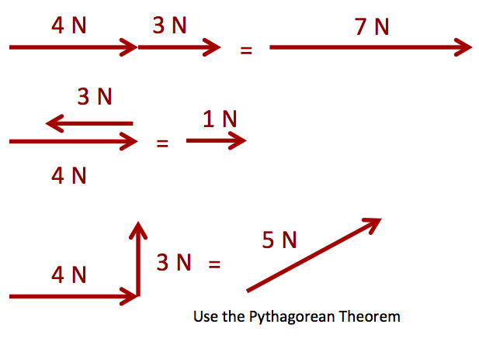

When the net force is _____, the forces are ____________.
velocity stays the same.
When the net force is ___ ____ the forces are _________.
velocity changes ACCELERATION OCCURS!!
Summary:

Questions: | Notes:
When the ____ are ________:

F_{NET} = ____ or ΣF = ____

The object is at rest so (v = 0 and a = 0) . . . . .

This is called ____ ________.

OR

The object moves at ____ ____ (v≠ 0 and a = 0) . . .

This is called ____ ________.

When The ____ are ____ ________:

F_{NET} ≠ ____ or ΣF ≠ ____

The velocity is ____ (a ≠ 0)

The object is ____ (velocity is changing)

This is called Disequilibrium.

Summary:

