Physics | Topic/ Objective:  Unit 3: Forces | Name:
 |  | Period: Date:
Essential Question: How can forces predict motion?
Questions: | Notes:
How do scientists describe and measure forces? | When forces are combined, COLINEAR forces can be added. Note: DIRECTIONS are established using (+) and (-) signs.  When forces are in opposite directions, the NET force is the in DIRECTION of the largest force.  When multiple forces act on object,  all of the forces can be added together to find the  NET FORCE (F_{NET} or $ΣF$) on the object.
How do forces combine?
Force Vector Addition Samples:

+ 4N + + 3N = + 7N

+ 4N + - 3N = + 1N
Magnitude: Angle: *
(4N)² + (3N)² = R² θ = tan ⁻¹ ( 3N/4N)
116N² + 9N² = R² θ = 37º
25N² = R²
5N = R * ALG II students only

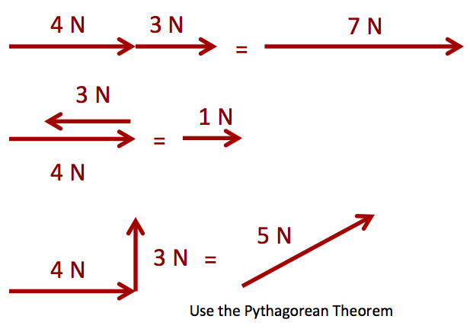

When the net force is ZERO, the forces are BALANCED .
velocity stays the same.
When the net force is NOT ZERO, the forces are UNBALANCED.
velocity changes ACCELERATION OCCURS!!
Summary: Objects accelerate in the direction of the net force. When forces are balanced, objects may at at rest OR moving at constant velocity. Objects can be moving at constant velocity or be at rest when forces are balanced.

Questions: | Notes:
When the FORCES are BALANCED:

F_{NET} = 0 or ΣF = 0

The object is at rest so (v = 0 and a = 0) . . . . .

This is called STATIC EQUILIBRIUM.

OR

The object moves at CONSTANT VELOCITY
(v≠ 0 and a = 0) . . .

This is called DYNAMIC EQUILIBRIUM.

When the FORCES are NOT BALANCED:

F_{NET} ≠ 0 or ΣF ≠ 0

The velocity is CHANGING (a ≠ 0)

The object is ACCELERATING (velocity is changing)

This is called Disequilibrium.

Summary:
Equilibrium means that forces are balanced. Static equilibrium always means that the object is at rest. Dynamic equilibrium means the object moves with constant velocity.

Disequilibrium means that forces are unbalanced. Objects in disequilibrium will ALWAYS be accelerating.

