Managing variables in a Friction Lab design: STATIC FRICTION

In our study of forces, you have learned that the friction force opposes motion or impending motion so it is in the opposite direction of motion or impending motion. So far, we have not distinguished between friction force based on the object’s motion.

When at object is at rest, the forces acting on it are balanced. If a force is applied to an object (see figure below) and it does not move, the friction force that impedes motion is called the static friction, f_{s} . When a static friction force acts on an object, the object is in static equilibrium.

The first step to designing a lab to measure STATIC friction will be to evaluate the variables.

Begin by examining the lab materials. List the all of variables for a STATIC friction lab before posing your experimental question or identifying the IV and DV.

Variables | What kind of Variable will this be in Lab design one? | How will you measure/control this variable?
 | Control? IV? DV?
Managing variables in a Friction Lab design: KINETIC FRICTION

In our study of forces, you have learned that the friction force opposes motion or impending motion so it is in the opposite direction of motion or impending motion. So far, we have not distinguished between friction force based on the object’s motion.

When at object is moving, the forces acting on it are balanced IF IT IS MOVING AT CONSTANT VELOCITY. If a force is applied to an object (see figure below) to make it move, the friction force that impedes motion is called the kinetic friction, f_{k} . When a kinetic friction force acts on an object, the object is in dynamic equilibrium if it moves at constant velocity or the object is in disequilibrium if it accelerates.

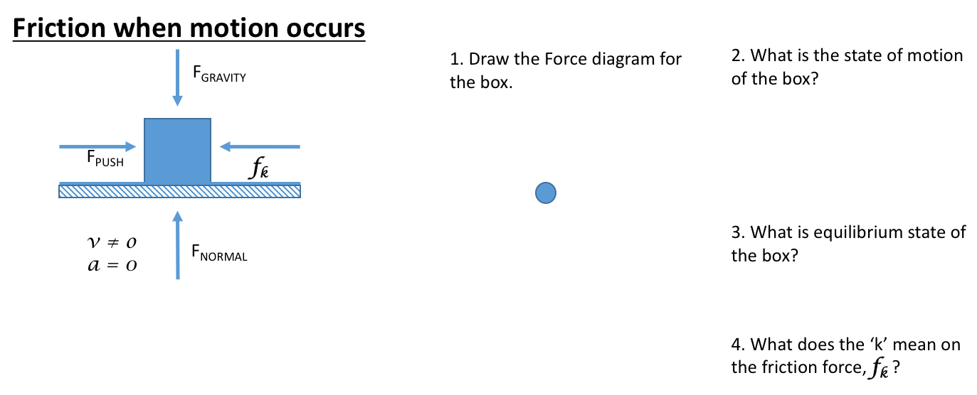
The first step to designing a lab to measure KINETIC friction will be to evaluate the variables.

Begin by examining the lab materials. List the all of variables for a KINETIC friction lab before posing your experimental question or identifying the IV and DV.

Variables | What kind of Variable will this be in Lab design one? | How will you measure/control this variable?
 | Control? IV? DV?

